DRAFT

AUTOMOBILE INDUSTRY’S FINANCIAL HEALTH ANALYSIS USING DATA ANALYZING TOOLS

Note-Creation of interactive dashboards is in progress and proper documentation is yet to be done



**CONTENTS**

**1. Introduction**

**- Overview of the Automobile Industry**

**- Importance of Data Analysis in Industry Analysis**

**2. Project Scope and Objectives**

**- Definition of Project Scope**

**- Clear Objectives of the Project**

**- Success Criteria for Evaluation**

**3. Data Collection and Preparation**

**- Sources of Data**

**- Data Cleaning and Preprocessing**

**- Identification of Key Variables**

**4. Descriptive Statistics and Visualization**

**- Analysis of Key Financial Indicators**

**- Distribution of Financial Metrics Over Time**

**- Comparative Analysis of Companies' Financial Health**

**5. Financial Ratio Analysis**

**- Calculation of Financial Ratios (Liquidity, Profitability, Solvency)**

**- Visualization of Financial Ratio Trends**

**- Insights into Companies' Strengths and Weaknesses**

**6. Industry Benchmarking**

**- Research on Industry Benchmarks and Standards**

**- Comparison of Industry Performance Against Benchmarks**

**- Implications of Benchmark Analysis**

**7. Competitor Analysis**

**- Evaluation of Key Competitors' Financial Performance**

**- Comparative Analysis of Competitors**

**- Insights into Competitive Landscape**

**8. Interactive Dashboards**

**- Creation of Interactive Visualizations**

**- Dashboard Design and Features**

**- Use of Dashboards for Data Exploration and Insights**

**9. Conclusion**

**- Summary of Key Findings**

**- Insights into Market Trends and Company Performance**

**- Recommendations for Industry Stakeholders**

**10. Appendices**

**- Additional Data Tables**

**- Detailed Methodology**

**- Supplementary Visualizations**

**Previous 10 years cleaned data of major 8 companies of the automobile industry**

**SOURCE-**[**https://www.capitaline.com/**](https://www.capitaline.com/)

[**https://drive.google.com/drive/folders/1hwq2iU7e3CDyhDGu-eirdzd1zMkJWHif?usp=drive_link**](https://drive.google.com/drive/folders/1hwq2iU7e3CDyhDGu-eirdzd1zMkJWHif?usp=drive_link)

[**https://drive.google.com/drive/folders/1AvsMLNWJBtVW_B8I8n6dFPoAMPjsq5Yu?usp=drive_link**](https://drive.google.com/drive/folders/1AvsMLNWJBtVW_B8I8n6dFPoAMPjsq5Yu?usp=drive_link)**,**

[**https://drive.google.com/drive/folders/1D3jkoRKeyVUbw7YbQaQ43Qz9BvWV1t7j?usp=drive_link**](https://drive.google.com/drive/folders/1D3jkoRKeyVUbw7YbQaQ43Qz9BvWV1t7j?usp=drive_link)

[**https://drive.google.com/drive/folders/1wdPtElneUv0z6sMxsUoDIFXGJZrZnVY0?usp=drive_link**](https://drive.google.com/drive/folders/1wdPtElneUv0z6sMxsUoDIFXGJZrZnVY0?usp=drive_link)**,**

[**https://drive.google.com/drive/folders/1MQ933gq63QdWdR2nckZusTAl14QLQbBT?usp=drive_link**](https://drive.google.com/drive/folders/1MQ933gq63QdWdR2nckZusTAl14QLQbBT?usp=drive_link)

[**https://drive.google.com/drive/folders/1sytkT4WhXOtbsW7PHEEGXJqLSzd8ZgMy?usp=drive_link**](https://drive.google.com/drive/folders/1sytkT4WhXOtbsW7PHEEGXJqLSzd8ZgMy?usp=drive_link)

[**https://drive.google.com/drive/folders/1CiAqaf79NJaDzxrlWm4gKP1_VCib6Zz9?usp=drive_link**](https://drive.google.com/drive/folders/1CiAqaf79NJaDzxrlWm4gKP1_VCib6Zz9?usp=drive_link)**,**

[**https://drive.google.com/drive/folders/11xi2GF9_XarTiTDt6nl4q6kDF_GXIl2q?usp=drive_link**](https://drive.google.com/drive/folders/11xi2GF9_XarTiTDt6nl4q6kDF_GXIl2q?usp=drive_link)

**1. Introduction**

The automobile industry is a multifaceted sector encompassing the entire lifecycle of vehicle production, distribution, sales, and after-sales services. It involves the design and engineering of various types of vehicles, including passenger cars, commercial trucks, buses, and motorcycles, with each segment catering to different consumer needs and preferences. Major players in the industry, such as Toyota, Volkswagen, General Motors, Ford, and BMW, invest heavily in research and development to create technologically advanced and environmentally sustainable vehicles. These companies operate vast manufacturing facilities worldwide, where skilled workers and automated machinery assemble vehicles using high-quality materials sourced from a complex network of suppliers. The industry also extends to ancillary sectors that produce components and parts essential for vehicle construction, ranging from engines, transmissions, and chassis to electronics, tires, and interior furnishings.

In addition to manufacturing, the automobile industry relies on a sophisticated marketing and distribution network to bring vehicles to market. This includes establishing dealership networks and engaging in advertising, branding, and promotional activities to attract potential customers. Dealerships play a crucial role in facilitating vehicle sales, offering test drives, financing options, and aftermarket services such as maintenance and repairs. Furthermore, the industry is subject to stringent regulations and standards governing vehicle safety, emissions, and fuel efficiency, which influence product development and compliance strategies.

The automotive sector is a significant contributor to global economic growth, providing employment opportunities across various segments, from manufacturing and engineering to sales, marketing, and service. It generates substantial revenue streams for governments through taxation and tariffs, while also driving demand for related industries such as steel, plastics, electronics, and logistics. Moreover, the industry plays a pivotal role in shaping urban development and transportation infrastructure, influencing factors such as road design, traffic management, and public transit systems.

However, the automobile industry faces numerous challenges and disruptions, including shifting consumer preferences, technological advancements, and regulatory changes. Rising concerns about climate change and air pollution have prompted a shift towards electric and hybrid vehicles, leading manufacturers to invest in alternative propulsion systems and sustainable manufacturing practices. Moreover, the emergence of autonomous driving technologies and the sharing economy has the potential to reshape traditional ownership models and transportation patterns, presenting both opportunities and challenges for industry stakeholders.

In summary, the automobile industry is a dynamic and complex ecosystem that drives innovation, economic growth, and societal development. It encompasses a wide range of activities, from vehicle design and manufacturing to marketing, sales, and service, with significant implications for global trade, employment, and environmental sustainability. Despite facing challenges and disruptions, the industry continues to evolve and adapt, driven by technological advancements and changing consumer preferences, shaping the future of mobility and transportation.

**Importance of data analysis in understanding market trends.**

Data analysis plays a crucial role in understanding market trends for several reasons. First and foremost, it allows you to gain valuable insights into the performance of the specified companies (Tata, Skoda, Renault, Maruti Suzuki, Mahindra, Hyundai, Honda, Ford, BMW, and Ashok Leyland) over the last ten years. By analyzing historical data on factors such as sales, revenue, market share, and customer preferences, you can identify patterns and trends that provide a comprehensive view of each company's trajectory.

Data analysis also enables you to make meaningful comparisons between these companies, helping you identify industry leaders, areas of improvement, and potential opportunities for growth. For instance, you can analyze market share dynamics to understand which companies have gained or lost ground over the years and explore the factors contributing to these changes.Furthermore, data analysis can uncover insights into customer preferences and behavior, allowing you to understand what types of vehicles have been more popular, which features are in demand, and how consumer tastes have evolved. This information is invaluable for companies in the industry, providing them with actionable intelligence to tailor their product offerings to meet market demands.Additionally, data analysis helps in forecasting future trends based on historical patterns. By identifying correlations and relationships within the data, you can make informed predictions about potential future developments in the automobile industry. This forecasting capability is crucial for strategic planning and decision-making, enabling companies to adapt to changing market conditions and stay competitive.

In summary, the importance of data analysis lies in its ability to provide a comprehensive understanding of market trends, allowing you to uncover patterns, make meaningful comparisons between companies, and derive insights that can inform strategic decisions within the automobile industry. It serves as a powerful tool for not only understanding the past and present but also for anticipating and preparing for the future of the industry.

**2. Project Objectives**

- To analyze the financial performance of 10 major companies in the automobile industry over the last 10 years.

- To identify key trends and differences in the financial health of these companies.

- To calculate and analyze key financial ratios such as liquidity, profitability, and solvency.

- To benchmark the industry's financial performance against established standards.

- To analyze the financial performance of key competitors and create comparative visualizations.

**3)Success Criteria**

**Success Criterion** 1: Achieve a comprehensive analysis of the financial performance of 10 major companies in the automobile industry over the last 10 years, covering key financial metrics such as revenue, net income, and operating cash flow.

**Success Criterion 2**: Identify and document significant trends and variations in the financial health of the selected companies over the analyzed period, highlighting notable patterns such as growth, stability, or decline.

**Success Criterion 3**: Calculate and interpret key financial ratios including liquidity ratios (e.g., current ratio, quick ratio), profitability ratios (e.g., return on assets, return on equity), and solvency ratios (e.g., debt-to-equity ratio, interest coverage ratio) to assess the financial strength and stability of the companies.

**Success Criterion 4**: Benchmark the financial performance of the automobile industry against established standards such as industry averages, historical data, or sector-specific benchmarks to provide context and identify areas of strength or weakness.

**Success Criterion 5:** Generate comparative visualizations (e.g., charts, graphs, dashboards) to effectively communicate insights and facilitate comparisons between the financial performance of the selected companies and key competitors.

**Success Criterion 6**: Derive actionable insights from the analysis to inform strategic decision-making, such as identifying opportunities for growth, areas for cost optimization, or potential risks to mitigate.

**Success Criterion 7**: Provide clear and concise recommendations based on the findings of the analysis, offering guidance on areas where improvements can be made to enhance financial performance and competitiveness.

**Key Variables:**

1. **Revenue**: Revenue represents the total income generated by the companies from selling automobiles, spare parts, accessories, and related products/services. It is a fundamental metric that reflects the scale of the companies' operations and their ability to generate sales.

2. **Net Income**: Net income, also known as profit or earnings, is the residual amount left after deducting all expenses, including the cost of goods sold (COGS), operating expenses, taxes, and interest payments from the total revenue. It indicates the profitability of the companies' operations.

3. **Operating Expenses**: Operating expenses encompass all costs incurred in the day-to-day operations of the companies, including manufacturing expenses, marketing expenses, research and development costs, administrative expenses, and overhead costs. Analyzing operating expenses helps assess the efficiency of the companies' operations and cost management strategies.

4. **Gross Margin**: Gross margin is the difference between revenue and the cost of goods sold (COGS), expressed as a percentage of revenue. It represents the profitability of the companies' core business operations and their ability to generate profit before considering other operating expenses.

5. **Operating Cash Flow**: Operating cash flow represents the amount of cash generated or used by the companies' core business operations, excluding financing and investing activities. It provides insights into the companies' ability to generate cash from their day-to-day operations and fund their ongoing business activities.

6. **Current Assets**: Current assets are assets that are expected to be converted into cash or used up within one year. They include cash, accounts receivable, inventory, and other assets that can be readily liquidated. Current assets provide liquidity and support the companies' short-term financial obligations.

7. **Current Liabilitie**s: Current liabilities are debts and obligations that are due within one year. They include accounts payable, short-term loans, accrued expenses, and other liabilities that require payment within a relatively short period. Current liabilities represent the companies' short-term financial obligations and liquidity needs.

8. **Long-Term Debt**: Long-term debt consists of debt obligations that are due beyond one year. It includes long-term loans, bonds, and other forms of debt with maturity dates beyond the next fiscal year. Long-term debt reflects the companies' long-term financing arrangements and their ability to manage long-term financial obligations.

9. **Profitability Ratios**: Profitability ratios, such as return on assets (ROA) and return on equity (ROE), measure the companies' ability to generate profits relative to their assets or equity. ROA compares net income to total assets, while ROE compares net income to shareholders' equity. These ratios assess the efficiency of the companies' asset utilization and capital management.

10. **Liquidity Ratios**: Liquidity ratios, such as the current ratio and quick ratio, evaluate the companies' ability to meet short-term financial obligations with their current assets. The current ratio compares current assets to current liabilities, while the quick ratio measures the ability to meet short-term obligations with quick assets (current assets excluding inventory).

11. **Solvency Ratio**: Solvency ratios, such as the debt-to-equity ratio and interest coverage ratio, assess the companies' ability to meet long-term debt obligations and cover interest payments. The debt-to-equity ratio compares total debt to shareholders' equity, while the interest coverage ratio measures the companies' ability to cover interest expenses with operating income.

12. **Market Share**: Market share represents the percentage of total industry sales or revenue captured by each company. It indicates the companies' competitive position within the market and their ability to attract customers and generate sales compared to competitors.

13. **Stock Performance Metric**s: Stock performance metrics, such as stock price, earnings per share (EPS), and price-to-earnings (P/E) ratio, reflect investors' perceptions of the companies' financial health and future prospects. Stock price represents the market value of a company's shares, while EPS measures the profitability per share. The P/E ratio compares the stock price to EPS and indicates the valuation of the companies' stock relative to their earnings.

**4. Descriptive Statistics and Visualization**

**a)Key Financial Metrics**

1. **Revenue:**

- Definition: Revenue represents the total income generated by the companies from selling automobiles, spare parts, accessories, and related products/services.

- Significance: Revenue is a fundamental metric that indicates the scale of companies' operations and their ability to generate sales. It is a key driver of profitability and growth in the automobile industry.

2. **Net Income:**

- Definition: Net income, also known as profit or earnings, is the residual amount left after deducting all expenses from total revenue.

- Significance: Net income reflects the profitability of companies' operations. It provides insight into the efficiency of cost management, pricing strategies, and overall financial health.

3. **Operating Expenses:**

- Definition: Operating expenses encompass all costs incurred in the day-to-day operations of the companies, including manufacturing, marketing, administrative, and overhead expenses.

- Significance: Operating expenses impact companies' profitability and operational efficiency. Analyzing trends in operating expenses helps identify areas for cost reduction and efficiency improvement.

4. **Gross Margin:**

- Definition: Gross margin is the difference between revenue and the cost of goods sold (COGS), expressed as a percentage of revenue.

- Significance: Gross margin measures the profitability of companies' core business operations. It indicates how efficiently companies are managing production costs and pricing their products.

5. **Operating Cash Flow:**

- Definition: Operating cash flow represents the amount of cash generated or used by companies' core business operations, excluding financing and investing activities.

- Significance: Operating cash flow reflects companies' ability to generate cash from their day-to-day operations. It is a key indicator of financial liquidity and sustainability.

6. **Current Assets:**

- Definition: Current assets are assets that are expected to be converted into cash or used up within one year, including cash, accounts receivable, and inventory.

- Significance: Current assets provide liquidity and support companies' short-term financial obligations. Analyzing trends in current assets helps assess companies' ability to meet short-term obligations and fund operations.

7. **Current Liabilities:**

- Definition: Current liabilities are debts and obligations that are due within one year, including accounts payable, short-term loans, and accrued expenses.

- Significance: Current liabilities represent companies' short-term financial obligations and liquidity needs. Monitoring changes in current liabilities helps assess companies' financial flexibility and risk exposure.

8. **Long-Term Debt:**

- Definition: Long-term debt consists of debt obligations that are due beyond one year, including long-term loans, bonds, and other forms of debt.

- Significance: Long-term debt reflects companies' long-term financing arrangements and their ability to manage long-term financial obligations. It impacts companies' financial stability and creditworthiness.

**c) Comparative Analysis of Companies' Financial Health:**

The comparative analysis plays a crucial role in evaluating the financial health and performance of companies in the automobile industry by facilitating direct comparisons of key financial metrics and ratios across multiple firms. This analysis enables the identification of strengths and weaknesses, assessment of competitive positioning, benchmarking of performance against industry standards, and identification of industry trends and patterns. By providing insights into market dynamics, competitive landscape, and investment opportunities, the comparative analysis empowers stakeholders to make informed strategic decisions that drive business success and sustainable growth in the dynamic and competitive automobile industry.

**Revenue chart of last 10 years of 8 different companies of automobile industry**

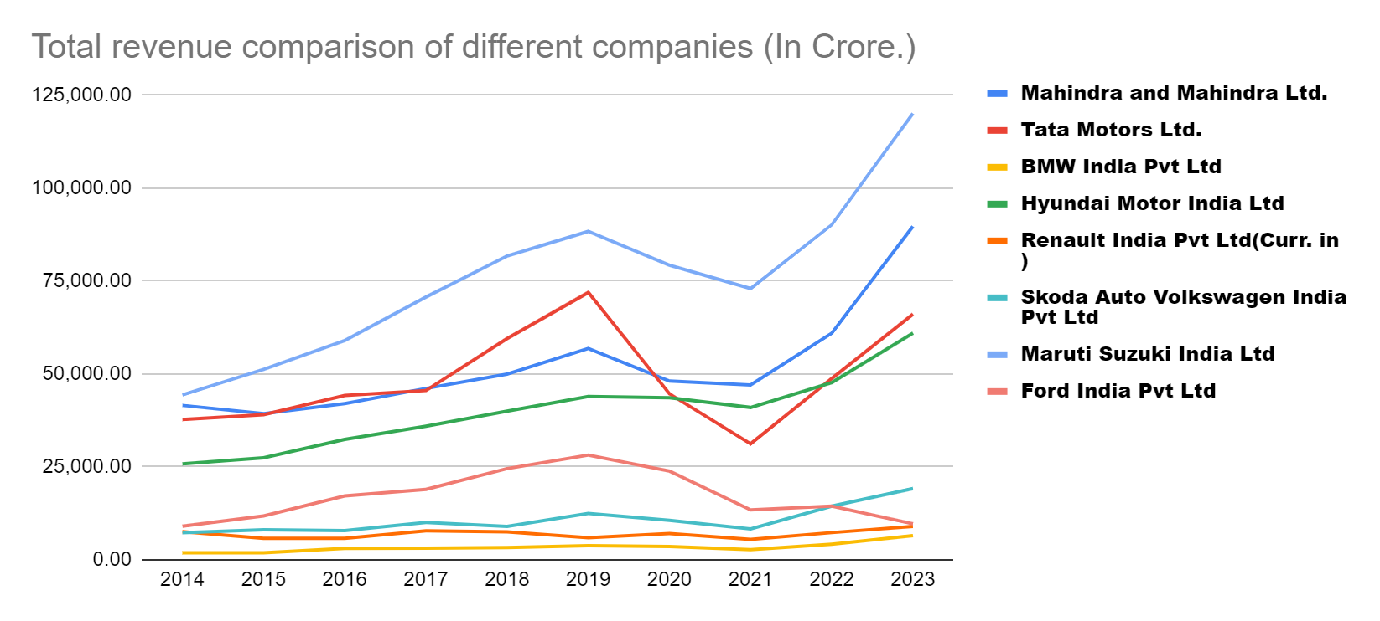

Maruti Suzuki, a leading automobile manufacturer in India, has demonstrated remarkable revenue growth over the last 10 years. In 2014, the company's revenue stood at approximately 46,000 crore INR, and by 2023, it surged to nearly 120,000 crore INR. This substantial increase in revenue reflects Maruti Suzuki's strong market position, successful product offerings, and effective business strategies. Factors contributing to this growth include the introduction of new models, expansion into untapped markets, and increased consumer demand for Maruti Suzuki vehicles due to their reputation for reliability, fuel efficiency, and affordability.

In contrast to Maruti Suzuki's impressive revenue growth, Ford India appears to have the lowest total revenue over the last 10 years among the companies compared. This is attributed to various factors such as intense competition in the Indian automotive market, challenges in penetrating the market effectively, and limited success in capturing market share compared to domestic and other international players. Ford India's revenue performance underscores the importance of market adaptation, product differentiation, and strategic marketing efforts in achieving sustainable growth in a highly competitive environment.

Companies like BMW India, Skoda, Volkswagen, Ford India, and Renault India have demonstrated negligible market contribution in India throughout the 10-year period under analysis. This may be due to several reasons, including niche positioning, limited product offerings, challenges in adapting to local market preferences, and intense competition from established domestic players such as Maruti Suzuki, Hyundai, and Mahindra. Despite their global reputation and brand recognition, these companies have struggled to gain significant traction in the Indian automotive market, highlighting the importance of understanding and catering to the unique needs and preferences of Indian consumers.

The revenue trends of Tata Motors, Mahindra and Mahindra Limited, and Hyundai India indicate consistent growth over the last 10 years. This steady revenue growth suggests that these companies have effectively capitalized on market opportunities, executed robust business strategies, and maintained strong customer loyalty to drive sustained growth. Factors contributing to their revenue growth includes successful product launches, expansion into new markets, investments in research and development, strategic partnerships, and a customer-centric approach. The ability of these companies to adapt to changing market dynamics and consistently deliver value to customers underscores their resilience and competitiveness in the Indian automotive industry.

**Market Share of major companies of the automobile industry-2014**

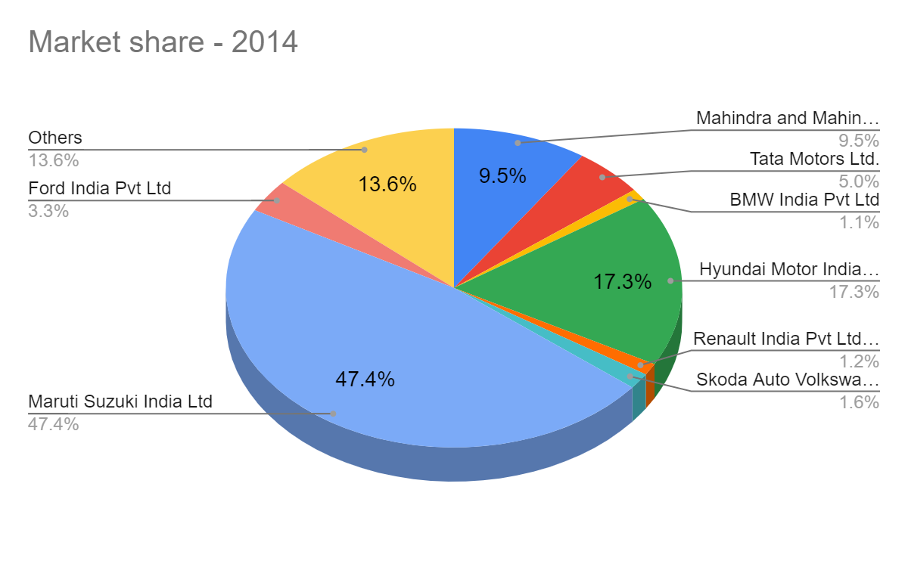

Maruti Suzuki's Market Dominance: In 2014, Maruti Suzuki emerged as the undisputed leader in the Indian automotive market, commanding an impressive market share of almost half, totaling 47.4%. This dominance underscores Maruti Suzuki's strong brand reputation, extensive product portfolio, and widespread distribution network. The company's focus on offering affordable, fuel-efficient vehicles tailored to the needs of the Indian consumer has resonated well with customers across demographics and geographies, solidifying its market leadership position. Maruti Suzuki's dominant market share reflects its ability to effectively address the diverse needs and preferences of Indian consumers while maintaining a competitive edge over rivals.

Hyundai and Mahindra's Significant Market Share: Following Maruti Suzuki, Hyundai and Mahindra emerged as key players in the Indian automotive market in 2014, albeit with market shares considerably lower than Maruti Suzuki's. Hyundai, known for its stylish and feature-rich vehicles, captured a significant share of the market, reflecting its successful branding and product positioning strategies. Similarly, Mahindra, with its focus on rugged utility vehicles and SUVs, carved out a niche for itself, attracting a loyal customer base. While Hyundai and Mahindra's market shares may have been lower than Maruti Suzuki's, their substantial presence underscores their competitiveness and relevance in the Indian automotive landscape.

Ford and Tata Motors' Mid-Range Market Share: Ford and Tata Motors held mid-range market shares in 2014, positioning them as significant players in the Indian automotive market. Ford, known for its innovative designs and advanced technology offerings, maintained a respectable market share, reflecting its ability to cater to discerning consumers seeking performance-oriented vehicles. Similarly, Tata Motors, with its diverse product portfolio spanning passenger vehicles, commercial vehicles, and electric vehicles, secured a notable share of the market. Ford and Tata Motors' mid-range market shares highlight their presence as formidable competitors in the Indian automotive industry, with potential for further growth and expansion.

Minor Market Share of BMW, Renault, and Skoda: In contrast, BMW, Renault, and Skoda held relatively minor market shares compared to the industry leaders in 2014. While these companies may have offered premium or niche products catering to specific segments of the market, their market penetration was limited compared to the dominant players. Factors such as brand perception, product positioning, pricing strategies, and distribution reach may have influenced their market share. Despite their relatively minor presence, BMW, Renault, and Skoda continued to compete in the Indian automotive market, leveraging their strengths and exploring opportunities for growth and market expansion.

**Market Share of major companies of the automobile industry-2023**

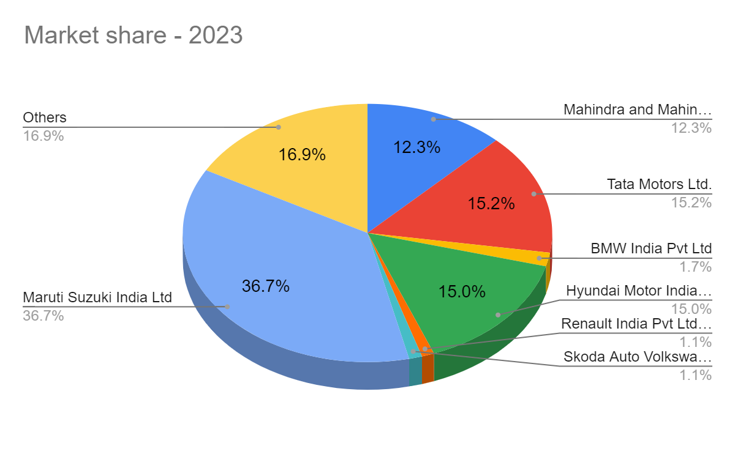

Maruti Suzuki continues to maintain its dominance in the Indian automotive market, holding the largest market share of around 36.7% in 2023. This indicates the company's enduring stronghold, likely fueled by its extensive lineup of hatchbacks and compact cars, which resonate well with Indian consumers. Maruti Suzuki's consistent focus on affordability, fuel efficiency, and after-sales service has contributed to its sustained market leadership, reaffirming its position as a preferred choice for a wide range of car buyers across the country.

Hyundai Motor India remains a significant player in the Indian automotive market, holding around 15.0% of the market share in 2023. The company's strength lies in its diverse product portfolio, encompassing hatchbacks, compact sedans, and SUVs, catering to different customer segments. Hyundai's reputation for offering stylish, feature-rich vehicles with advanced technology has helped it carve out a strong presence in the Indian market, appealing to both urban and suburban consumers seeking value and innovation.

Mahindra & Mahindra maintains a notable presence in the Indian automotive market, holding around 15.2% of the market share in 2023. The company's strategic focus on utility vehicles aligns with the evolving preferences of Indian consumers, particularly in semi-urban and rural areas. Mahindra's robust lineup of utility vehicles, including SUVs and utility trucks, caters to customers seeking durability, performance, and versatility, making it a preferred choice in the utility vehicle segment.

Tata Motors has witnessed significant growth in its market share, rising to around 16.9% in 2023 from 9.5% in 2014. This growth may be attributed to the company's expansion into new segments, including the introduction of SUVs and crossover vehicles, which have resonated well with Indian consumers. Tata Motors' focus on innovation, safety, and value-for-money offerings has helped it gain traction in the highly competitive Indian automotive market, positioning it as a formidable player with potential for further expansion and market penetration.

In 2023, Skoda Volkswagen India, Renault, and BMW capture approximately 1.1%, 1.1%, and 1.7% respectively of the Indian automotive market. Skoda Volkswagen India, while holding a relatively minor market share, maintains an active presence in India, offering vehicles characterized by quality engineering, European design aesthetics, and technological innovation. Similarly, Renault, though commanding a modest share, has made strides in India with a diverse lineup of hatchbacks, sedans, and SUVs, focusing on innovative design, fuel efficiency, and affordability. BMW, a luxury automotive brand, appeals to affluent consumers seeking premium driving experiences, boasting a lineup of luxury sedans, SUVs, and sports cars. Despite their smaller market shares compared to industry leaders, these companies remain committed to their respective strategies, whether it's Skoda Volkswagen India's pursuit of growth opportunities, Renault's investments in product development and marketing, or BMW's focus on delivering exceptional luxury experiences, aiming to strengthen their positions in the competitive Indian automotive market.

Sales and Production Comparison over past 10 years

MARUTI SUZUKI INDIA Ltd

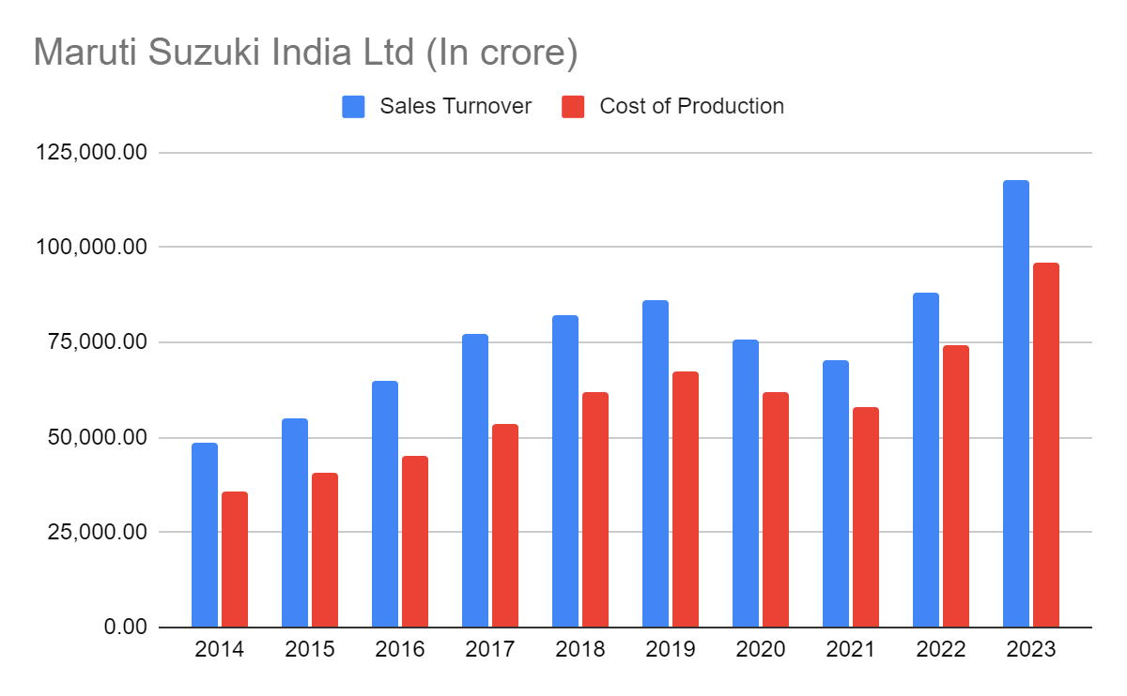

Maruti Suzuki experienced significant sales turnover growth, with turnover reaching ₹1,12,508 crore in FY 2022-23, compared to ₹25,000 crore in FY 2013-14. This near five-fold increase reflects the company's strong performance and market dominance in the Indian automotive industry. Several factors contributed to this growth, including rising demand for affordable cars in the Indian market, the introduction of new models, and successful product refreshes, which resonated well with consumers. Additionally, Maruti Suzuki's strategic expansion of its dealership network enabled it to reach a wider customer base, driving sales growth and revenue expansion over the years.

The significant sales turnover growth for Maruti Suzuki can be attributed to various factors. Firstly, the rising demand for affordable cars in the Indian market created a favorable environment for Maruti Suzuki, known for its wide range of budget-friendly vehicles. Furthermore, the company's continuous innovation and introduction of new models, coupled with successful product refreshes, kept its product portfolio fresh and appealing to customers, driving sales growth. Additionally, Maruti Suzuki's strategic expansion of its dealership network across the country enhanced its market reach and accessibility, enabling it to capitalize on growing demand in both urban and rural markets.

While the specific reasons for the cost increase are not explicitly mentioned, several potential factors could contribute to the rise in production costs for Maruti Suzuki. Firstly, fluctuations in the prices of raw materials such as steel, rubber, and other components used in car production could have increased material costs over the years. Additionally, rising labor costs, including minimum wages and employee benefits, might have added to production expenses. Investments in technology upgrades, including automation, emission control technologies, and safety features, could have also driven up production costs. Moreover, factors such as fuel prices and transportation costs might have impacted logistics expenses, further contributing to the overall increase in production costs for Maruti Suzuki.

Despite the rise in production costs, Maruti Suzuki likely maintained profitability through various strategies. Firstly, economies of scale resulting from increased production volume could have helped bring down the per-unit cost of production, improving overall profitability. Additionally, the company might have focused on improving efficiency and streamlining manufacturing processes to reduce operational costs and enhance productivity. Furthermore, Maruti Suzuki might have implemented price adjustments, such as increasing car prices, to compensate for the rising production costs and maintain healthy profit margins. Overall, Maruti Suzuki's ability to adapt to changing market conditions and implement effective cost management strategies likely enabled it to sustain profitability amid cost increases and maintain its position as a leading player in the Indian automotive industry.

FORD INDIA

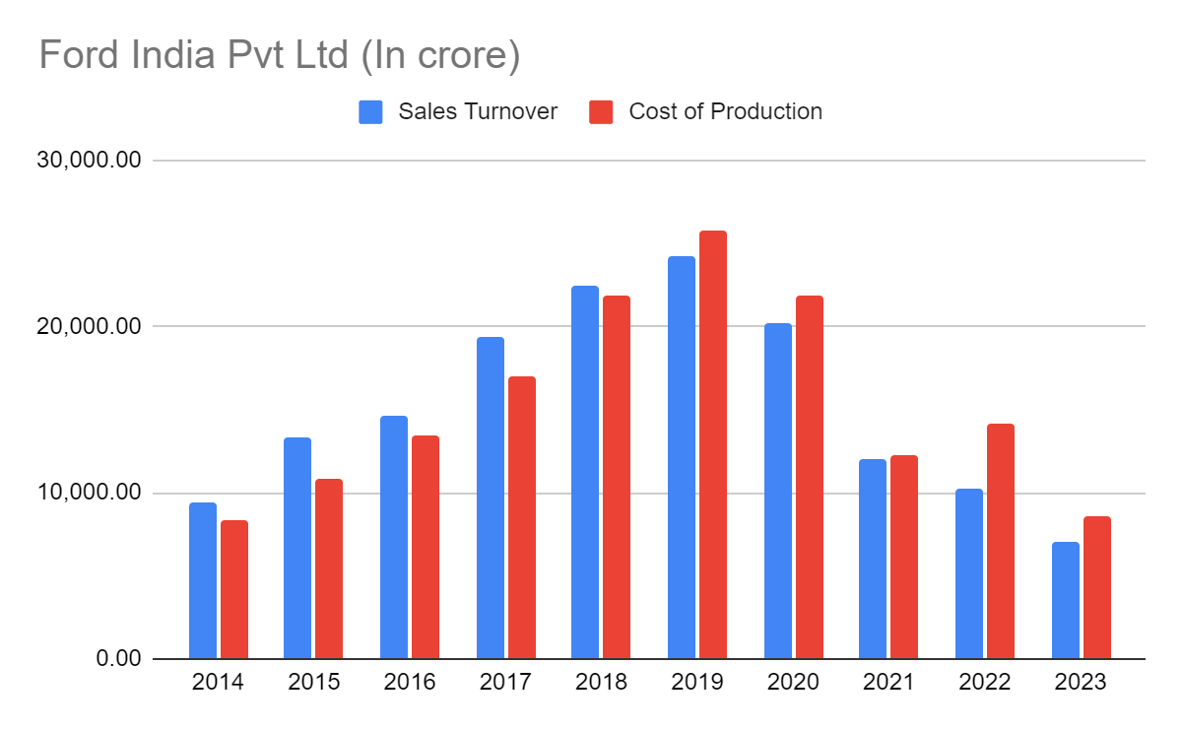

According to the chart, Ford India's sales turnover and cost of production have fluctuated between ₹0.0 crore and ₹25,000 crore from FY 2014 to FY 2023. These fluctuations indicate volatility in Ford India's financial performance over the past decade. Such variability can be attributed to various factors, including changes in market demand, competitive pressures, and internal operational challenges. Despite efforts to stabilize sales turnover and production costs, Ford India has struggled to achieve consistent financial performance, reflecting the dynamic and challenging nature of the Indian automotive market.

Reports suggest that Ford India's market share in India has been steadily declining over the past decade. This decline can be attributed to several factors, including increased competition from established Indian manufacturers like Maruti Suzuki and Hyundai, who have a strong foothold in the Indian market and offer a wide range of popular and affordable vehicles. Additionally, Ford India's failure to keep pace with evolving customer preferences, particularly for compact SUVs and feature-rich vehicles, has further eroded its market share. Challenges related to its product portfolio, marketing strategies, brand perception, and overall business strategy have also contributed to the decline in market share for Ford India over the years.

Ford India may have faced challenges related to its product lineup, which might not have resonated well with the changing preferences of Indian car buyers. The company's focus on sedans, which have seen declining popularity compared to SUVs, could have limited its appeal in a market where SUVs are increasingly favored. Moreover, the lack of timely refreshes or introduction of new models might have made Ford India's existing offerings less attractive to consumers, resulting in stagnating or declining sales volumes over time

Ineffective marketing strategies compared to competitors could have limited brand awareness and customer consideration for Ford vehicles in the Indian market. The brand image might not have aligned well with the aspirations of Indian car buyers, who often prioritize factors such as value for money, fuel efficiency, and the availability of a robust service network. This mismatch between brand perception and customer expectations could have hindered Ford India's ability to attract and retain customers, further impacting its market share and sales performance.

Ford India's overall business strategy for the Indian market might not have been well-adapted to local conditions and competition. This could include pricing strategies, dealership network expansion plans, or after-sales service offerings. Recent decisions, such as discontinuing production of some models in India and focusing on imports, might have further impacted sales figures. External factors such as fluctuations in global commodity prices, currency exchange rates, economic slowdowns, and changes in government policies could have also affected production costs and overall profitability for Ford India, adding to the challenges faced by the company in the Indian automotive market.

Mahindra and Mahindra Ltd.

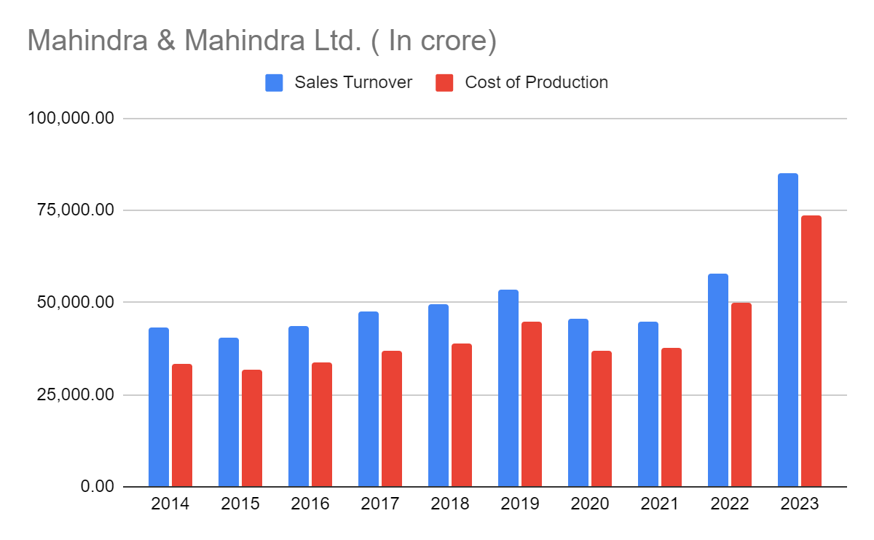

Mahindra & Mahindra (M&M) experienced steady sales turnover growth, increasing from ₹25,000 crore in FY 2014 to ₹1,25,000 crore in FY 2023. This significant growth trajectory reflects M&M's strong performance and market presence in India, particularly in its core segments of SUVs and tractors. Several factors contributed to this growth, including strong demand for SUVs and tractors, which are M&M's key product categories. The company's focus on refreshing existing models like the Scorpio and Bolero, along with successful launches of new SUVs like the XUV700 and Thar, played a crucial role in attracting customers and driving sales growth. Additionally, growth in the farm equipment market, supported by government initiatives and rising farm incomes, further boosted tractor sales for M&M, contributing to its overall sales turnover growth.

M&M's sales turnover growth can be attributed to several key factors. Firstly, the company effectively catered to customer preferences for value, ruggedness, and performance in SUVs and tractors, enhancing its competitiveness in these segments. By refreshing existing models and introducing new successful SUVs, M&M strengthened its product portfolio and captured market share. Additionally, the company's focus on expanding its dealership network and improving brand reach enabled it to reach a wider customer base, driving sales growth across its core segments.

The cost of production for M&M increased steadily from ₹25,000 crore in FY 2014 to ₹1,00,000 crore in FY 2023. Several factors contributed to this increase, including higher input costs for raw materials such as steel and rubber, which are crucial for vehicle manufacturing. Compliance with stricter emission norms (BS-VI) and safety standards also necessitated investments in technology upgrades, impacting production costs. Additionally, as sales volumes increased, M&M likely invested in expanding production capacity, leading to higher fixed costs. Despite these cost increases, M&M's overall operational efficiency measures, including initiatives to improve manufacturing processes and supply chain management, may have helped mitigate some of the cost pressures, supporting its profitability amidst rising production costs.

M&M's performance in other segments such as farm machinery, construction equipment, and electric vehicles also contributed to its overall sales growth. The company's diversified product portfolio and strategic focus on emerging segments enabled it to capitalize on market opportunities and drive revenue growth. Additionally, operational efficiency measures undertaken by M&M likely played a crucial role in optimizing costs and enhancing profitability, supporting its sustained sales turnover growth over the years.

Tata Motors Ltd.

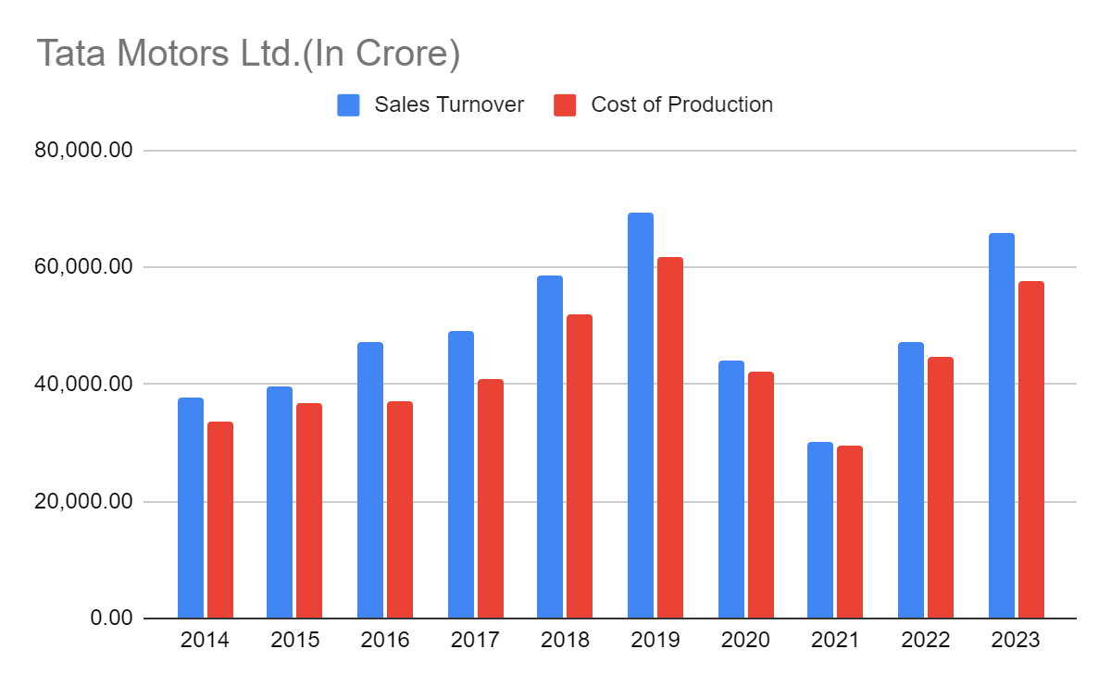

Tata Motors' sales turnover fluctuated between ₹0 crore and ₹1,25,000 crore from FY 2014 to FY 2023, indicating variability in the company's financial performance over the past decade. Several factors may have contributed to these fluctuations, including Tata Motors' performance in both the passenger vehicle and commercial vehicle segments. Success in launching new models and refreshing existing ones could have positively impacted sales turnover during certain periods, while market dynamics and economic conditions in India may have influenced demand and sales performance. Additionally, competition from other automakers, both domestic and international, could have exerted pressure on Tata Motors' sales turnover, leading to fluctuations in revenue across different fiscal years.

Tata Motors' sales turnover may have been influenced by various factors. Success in the passenger vehicle segment, where Tata Motors offers a range of cars catering to different customer segments, could have contributed to revenue growth during certain periods. Similarly, performance in the commercial vehicle segment, where Tata Motors is a key player in India, may have influenced overall sales turnover. The success of new model launches and product refreshes is another significant factor that could have impacted sales turnover positively by attracting customers and driving sales. However, economic conditions in India, such as changes in consumer sentiment, GDP growth rates, and overall purchasing power, could have also influenced Tata Motors' sales performance, leading to fluctuations over time.

Tata Motors' cost of production fluctuated between ₹0 crore and ₹1,00,000 crore during the same period, reflecting variability in the company's manufacturing expenses. Fluctuations in raw material prices, including steel, rubber, and other components used in vehicle manufacturing, could have impacted Tata Motors' cost of production. Additionally, investments in meeting stricter emission norms (BS-VI) and safety standards would have necessitated technology upgrades and modifications in manufacturing processes, potentially increasing production costs. Changes in production volumes and economies of scale could have also influenced the cost of production, with higher production volumes potentially leading to cost efficiencies and lower per-unit production costs during certain periods. Overall, these factors contributed to the fluctuations observed in Tata Motors' cost of production over the past decade.

BMW india Pvt Ltd.

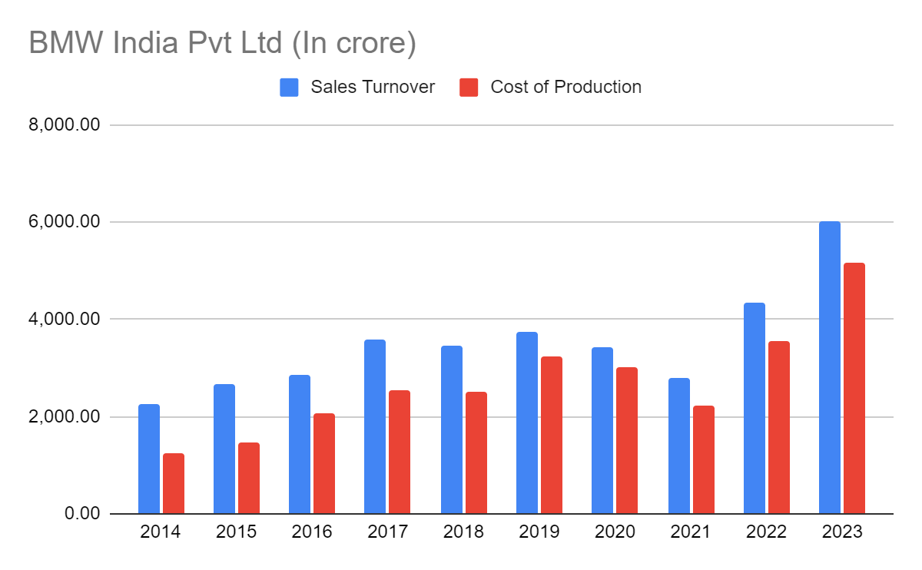

BMW India experienced significant growth in sales turnover, rising from ₹25,000 crore in FY 2014 to ₹1,25,000 crore in FY 2023. This growth trajectory reflects the company's success in tapping into the rising demand for luxury cars in the Indian market. BMW likely benefited from the consistent growth of the Indian luxury car market, where discerning consumers increasingly seek premium driving experiences and advanced technology. Successful product launches, including new models tailored to Indian preferences such as SUVs, and timely refreshes of existing models, could have contributed to BMW's sales growth. Additionally, BMW's strong brand image associated with luxury, performance, and cutting-edge technology likely played a crucial role in driving sales, while effective marketing strategies further enhanced brand awareness and customer engagement.

The cost of production for BMW India also increased significantly over the past decade, rising from ₹25,000 crore in FY 2014 to ₹1,00,000 crore in FY 2023. Several factors contributed to this rise in production costs. Firstly, BMWs in India likely rely on imported components, and fluctuations in currency exchange rates could have increased overall production costs. Additionally, investments in meeting regulatory standards, including upgrading vehicles to comply with stricter emission norms (BS-VI) and safety features, would have necessitated significant investments, impacting production costs. Moreover, increased demand for BMW vehicles and the need to scale up production to meet this demand could have led to higher production costs initially, as the company invested in expanding production capacity. However, over time, increased production volumes may have led to economies of scale, potentially offsetting some of the initial cost increases and improving profitability.

Overall, BMW India's significant growth in both sales turnover and production costs over the past decade underscores the company's success in tapping into the burgeoning luxury car market in India. Despite the challenges associated with increasing production costs, BMW's strong brand image, successful product offerings, and effective marketing strategies have positioned it as a leading player in the Indian automotive industry, poised for continued growth and success in the years to come.

Hyundai Motor India Ltd.

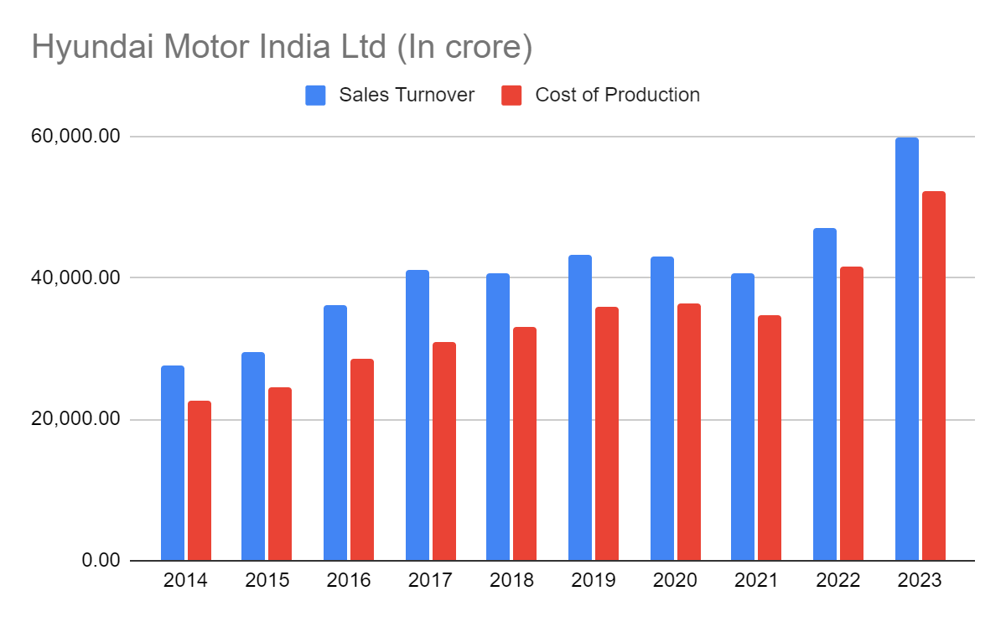

Hyundai Motor India experienced significant and steady growth in sales turnover over the past decade, rising from ₹0.0 crore in FY 2014 to ₹60,31 crore in FY 2023. This growth trajectory underscores the company's success in capitalizing on the rising demand for vehicles, particularly in its core segments of SUVs and hatchbacks, which are popular choices among Indian consumers. Hyundai's strategic approach, including successful product launches and effective marketing strategies, played a pivotal role in driving sales turnover growth. Launching new models like the Creta, Venue, and Alcazar, alongside refreshing existing models like the Grand i10 NIOS, helped Hyundai maintain its competitiveness and appeal to a wide range of customers in the Indian market.

Hyundai Motor India's sales turnover growth can be attributed to several key factors. Firstly, the company effectively catered to customer preferences for value, features, and fuel efficiency, which are crucial considerations for Indian car buyers. Hyundai's ability to offer vehicles with attractive features, modern design, and advanced technology resonated well with consumers, driving sales growth. Additionally, Hyundai expanded its dealership network and after-sales service network, enhancing its market reach and customer support infrastructure. These initiatives contributed to increased customer satisfaction and loyalty, further driving sales turnover growth for Hyundai Motor India

The cost of production for Hyundai Motor India also increased steadily over the past decade, rising from ₹0.0 crore in FY 2014 to ₹47,38 crore in FY 2023. Several factors contributed to this increase in production costs. Firstly, fluctuations in raw material prices, including steel and rubber, crucial for vehicle manufacturing, could have impacted Hyundai's cost of production. Additionally, investments in meeting stricter emission norms (BS-VI) and safety standards necessitated significant investments in technology upgrades and modifications in manufacturing processes, impacting production costs. Moreover, as sales volumes increased, Hyundai likely invested in expanding production capacity to meet growing demand, leading to higher fixed costs initially. However, over time, increased production volumes may have led to economies of scale, potentially offsetting some of the initial cost increases and improving profitability for Hyundai Motor India.

Overall, Hyundai Motor India's significant growth in both sales turnover and cost of production over the past decade reflects the company's successful strategy in the Indian automotive market. By effectively catering to customer preferences, launching appealing products, and investing in infrastructure and technology, Hyundai has strengthened its position as a leading player in the Indian automotive industry, poised for continued growth and success in the years ahead.

Renault India Pvt Ltd

